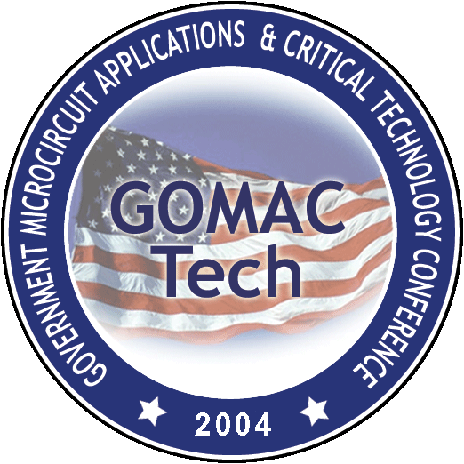

Verification of U.S. Citizenship or Permanent Residence

I,______________________, certify that I am a U.S. Citizen or a legal Permanent Residence of the United States of America. This document has been prepared to verify citizenship/residence for the upcoming GOMACTech-04 Conference.

Individual Nondisclosure Agreement for GOMACTech-04

By signing this agreement, I agree to protect all proprietary, business sensitive, and government export controlled information (hereinafter referred to as “information”), either written or verbal, supplied to me or coming to my possession regarding the GOMACTech-04 Conference held in Monterey, CA on March 1518, 2004.

I understand that my violation of the terms and conditions of this agreement may result in disciplinary action against me. I acknowledge that I may incur criminal or civil liability to the United States Government for the improper disclosure of information.

This agreement shall become effective on the date indicated below.

Printed Name________________________
Signature____________________________
Date:________________________________

