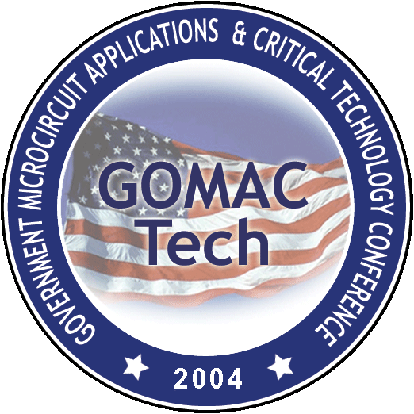
GOMACTech-04
Transformational Technologies
15-18 March 2003, Monterey, CA

Conference Chairman’s Report
28 May 2003

Conference Chairman Zach Lemnios, DARPA
Technical Program Chairman Edgar Martinez, DARPA
Treasurer Gerald Borsuk, NRL
Secretary Carl Kotecki, NASA-GSFC
Award Chairman Loren Linholm, NIST
Social Chairman Sammy Kayali, NASA/JPL
Exhibit Chair / Conference Support Ralph Nadell, Palisades

GOMACTech-03 was most successful, with 494 attendees and net profit approaching $64k. This was due in large measure to the leadership of Eric Adler as the Conference Chairman and the diligence and hard work of the Technical Program Committee and the Session Chairs.

Soon after GOMACTech-03, we were saddened with the news of the passing of our friend and colleague, Bill Schneider. Bill would have been the Technical Program Chair for GOMACTech-04 and had already begun to contact candidate session chairs and frame the technical program. We are fortunate that Dr. Edgar Martinez of DARPA/MTO has stepped forward to serve. On May 12, 2003, the Steering Committee overwhelmingly endorsed the nomination of Edgar Martinez as the Technical Program Chair for GOMACTech-04 and General Chair for GOMACTech-05. Edgar has diligently drafted Session Chairs and is shaping the technical program.

The Steering Committee will work closely with the Technical Program Committee to assure a successful conference in ’04. Furthermore, the Steering Committee will address a review and perhaps refinement of the GOMAC By-laws to align them with our recent conference model and agency participation. I plan to hold three Steering Committee meetings before GOMACTech-04 and will schedule those to coincide with other GOMACTech meetings to maximize the effectiveness of our meetings. I anticipate that we will grow our Steering Committee membership this year to include new agencies and reinvigorate participation from our current membership.

