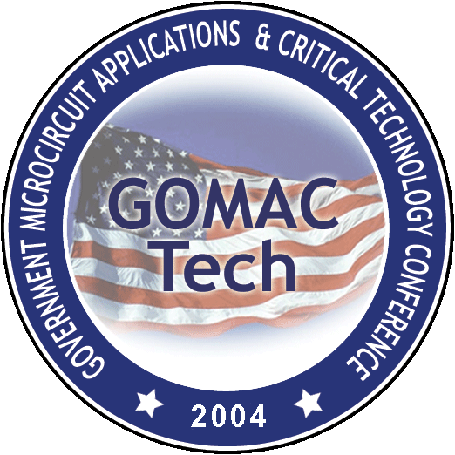
GOMACTech-04
Transformational Technologies

Steering Committee Meeting
28 May 2003
CACI Inc., 3811 North Fairfax Drive, Suite 800
Arlington, Virginia
(703) 276-4747

10:00 am Z. Lemnios Call to Order

C. Kotecki Previous Minutes
Z. Lemnios Chair’s Report
G. Borsuk Treasurer’s Report (deferred to 1pm)

10:30 am Old Business

R. Nadell Audit of treasurer accounts
R. Nadell $125K GOMACTech-04 top down budget
R. Nadell Revise paper clearance forms to indicate ITARS
R. Nadell Formulate position on Canadian ITARS participation
L. Linholm By-Law Subcommittee
TPC Selection of session chairs (Deferred to new business)
Z. Lemnios Invite DHS, NSA, DDR&E (Ray Price) to participate
A. Campbell Invite DOE to participate

11:15 am New Business – GOMACTech-03 Follow up

D. Palmer GOMACTech-03 Questionnaire Results
L. Linholm GOMACTech-03 Best Paper Award
R. Nadell GOMACTech-03 Financial Report

(working lunch)

12:15 pm New Business – GOMACTech-04

E. Martinez GOMACTech-04 Technical Program
TPC meetings
Session Chairs Plenary Session
Technical Sessions Keynote Speaker
Kilby Lecturer Tutorials

S. Kayali GOMACTech-04 Local Arrangements and Social Events
R. Nadell Exhibit Update
G. Sheppard GOMACTech Web Site Update

Other New Business
Meeting Timetable
Site for GOMACTech-05

2:30 pm Adjourn

