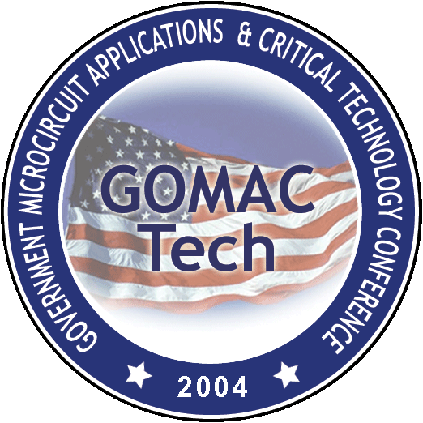
GOMACTech-04
Combined Steering Committee&
Technical Program Meeting

Booz Allen Hamilton
3811 North Fairfax Drive, Suite 600
Arlington, Virginia
(703) 816-5200

S. Kayali Local arrangements and social events

Wednesday 2/17/04 Dinner @ Monterey Aquarium 7:30 – 10:00 PM

2 food stations
1 Desert and Coffee station

Thursday 3/18/04 - Committee dinner
Plan for 20 people
Fresh Cream (Monterey)
French Restaurant
Entrée – $30 per person
Extensive Wine List
Private Rooms for 20, 24, 30 and 40 guests
Please provide confirmation for restaurant and number of people

Tuesday 3/16/04 - Color guard
Contacted NPS
Received response and Working the details

